

What can we help you achieve?
HIGHER EDUCATION

Temple University
Class Schedule Training Workbook
Updated 8/16/2010

_________________________________________________________________________________________________________________

SunGard Higher Education
4 Country View Road
Malvern, Pennsylvania 19355
United States of America
(800) 522 - 4827

Customer Support Center website
http://connect.sungardhe.com

Distribution Services e-mail address
distserv@sungardhe.com

Other services
In preparing and providing this publication, SunGard Higher Education is not rendering legal, accounting, or other similar professional services. SunGard Higher Education makes no claims that an institution's use of this publication or the software for which it is provided will insure compliance with applicable federal or state laws, rules, or regulations. Each organization should seek legal, accounting and other similar professional services from competent providers of the organization's own choosing.

Trademark
Without limitation, SunGard, the SunGard logo, Banner, Campus Pipeline, Luminis, PowerCAMPUS, Matrix, and Plus are trademarks or registered trademarks of SunGard Data Systems Inc. or its subsidiaries in the U.S. and other countries. Third-party names and marks referenced herein are trademarks or registered trademarks of their respective owners.
Revision History Log
Publication Date | Summary
April 2008 | New version that supports Banner 8 software.
May 2009 | Miscellaneous edits for readability, addition of Section Syllabus and Text, Update OLR, SME review additions.
September 2009 | Correct Linking Sections on p. 121 per SME request

Notice of rights
Copyright © SunGard Higher Education 2008. This document is proprietary and confidential information of SunGard Higher Education Inc. and is not to be copied, reproduced, lent, displayed or distributed, nor used for any purpose other than that for which it is specifically provided without the express written permission of SunGard Higher Education Inc.


Table of Contents

Goals & Objectives 4
Learning Objectives 5
General Forms Overview 6
Introduction 6
Banner Scheduling Forms 6
Navigation 7
Basic Scheduling Data Entry 10
Scheduling a Section of a Course 10
Assigning Enrollment Information 14
Reserving Seats 16
Assigning Meeting Times, Rooms & Instructors 18
Assigning Sections to an Instructor 22
Creating Multiple Sections of a Course 24
Special Scheduling Data Forms 30
Adding Specialized Features to Sections 30
Registration Restrictions at the Schedule Level 31
Maintaining Section Syllabus Information 33
Creating Section Comments 35
Cross Listing Sections 37
Creating Blocks 40
Query Only Scheduling Forms 42
Listing Sections in a Term 42
Listing Sections by Building and Room 42
Listing Sections with Reserved Seating 43
Listing Faculty Sections in a Term 43
Listing Cross Listed Sections 44
Listing Cross Listed Sections by Meeting Time 44
Listing Block Schedules in a Term 45
Listing Block Schedule Sections in a Term 45
Self Service Banner (SSB) Class Schedule 46
Summary 48
Self Check 49
Answer Key for Self Check 51
Appendix 53
Forms Job Aid 53
More on Navigation 58
Current State vs. Future State 60

Goals & Objectives
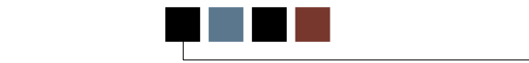
Course goal
The goal of this training is to provide you with the knowledge and practice to setup and maintain a schedule of classes at your institution. Training is divided into four sections:
- General Forms Overview
- Basic Data Entry
- Specialized Scheduling Data
- Query Only Forms
Intended audience

Personnel from offices responsible for maintaining schedule information.
Prerequisites
To complete this course, you should have
- completed the Education Practices computer-based training (CBT) tutorial Banner 8 Fundamentals, or have equivalent experience navigating in the Banner system
- obtained administrative rights to create and perform the necessary set up in Banner

Learning Objectives
As the person responsible for maintaining schedule information for your departments, you will learn to open and create sections, enter days/times, location and instructors. By the end of this training session you will also be able to add section comments, define registration restrictions at the section level, cross-list sections, and create blocks.

General Forms Overview
Introduction
The purpose of this section is to familiarize you with the forms that you will be using routinely to create and revise your sections and Class Schedule. Those listed here will be used to enter required data as well as optional features. Query only forms are also included.
Banner Scheduling Forms
Basic Schedule forms:
SSASECT – Course Section Information tab –
Campus, Schedule Type and Part of Term required
Section Enrollment Information tab –
Maximum Seats required; Reserved Seats optional
Meeting Times and Instructors tab –
Meeting Dates, including ARR, are required to enter an instructor ID
Location and Credits – Location entered through R25; Credits added for ARR sections

Optional Scheduling forms:
SIAASGN – Faculty Assignment
SSABLCK – Block Schedule Control
SSARRES – Schedule Restrictions
SSASYLB – Section Syllabus
SSATEXT – Section Comment
SSAXLST – Schedule Cross List Definition

Query only forms:
SIAASGQ – Faculty Schedule Query
SSABLKQ – Block Schedule Query
SSABSCQ – Block Schedule Section Query
SSAMATX – Building/Room Schedule
SSASECQ – Schedule Section Query
SSAXLSQ – Schedule Cross List Query
SSAXMTI – Cross List Meeting Time/Instructor Query
SSIRESV – Reserved Seat Inquiry
Navigation
Learning to navigate the Banner forms is essential to success in this environment. The icons located at the top of each form play an important part in the navigation of Banner forms. Consequently, a brief introduction to navigation is included in scheduling training. A general navigation training session is also in tuportal.temple.edu. Click on Help?, click on “General Banner and Portal” and select “Navigating the Banner Toolbar”.

Perhaps the most important and most frequently icon used is “Next Block”, ninth from the left. You can also execute next block by using the Control and Page Down keys or by clicking on the word Block above the row of icons and clicking on “Next”.

- As you place your cursor over an icon, the name of the function will appear. See the arrow and the caption in the image below.

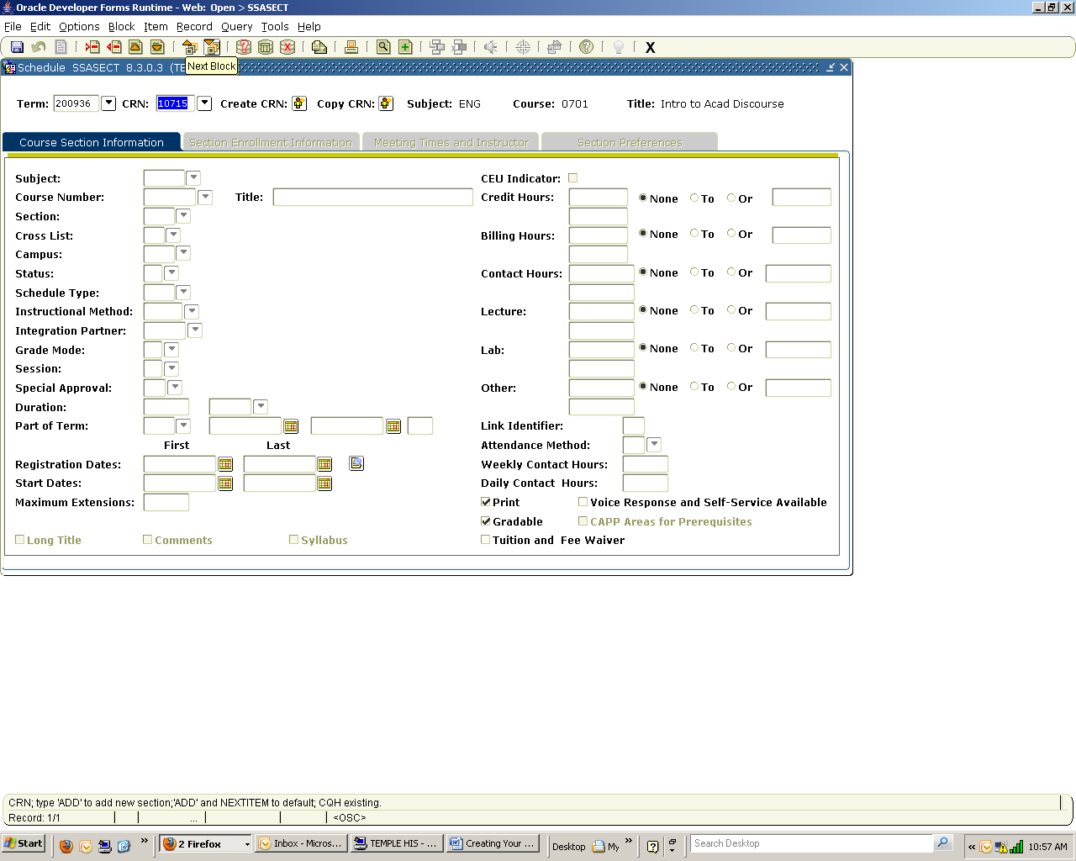

Another frequently used icon is Rollback (the back arrow or second icon on the left). This feature is used to return a blank version of the form you have just completed.

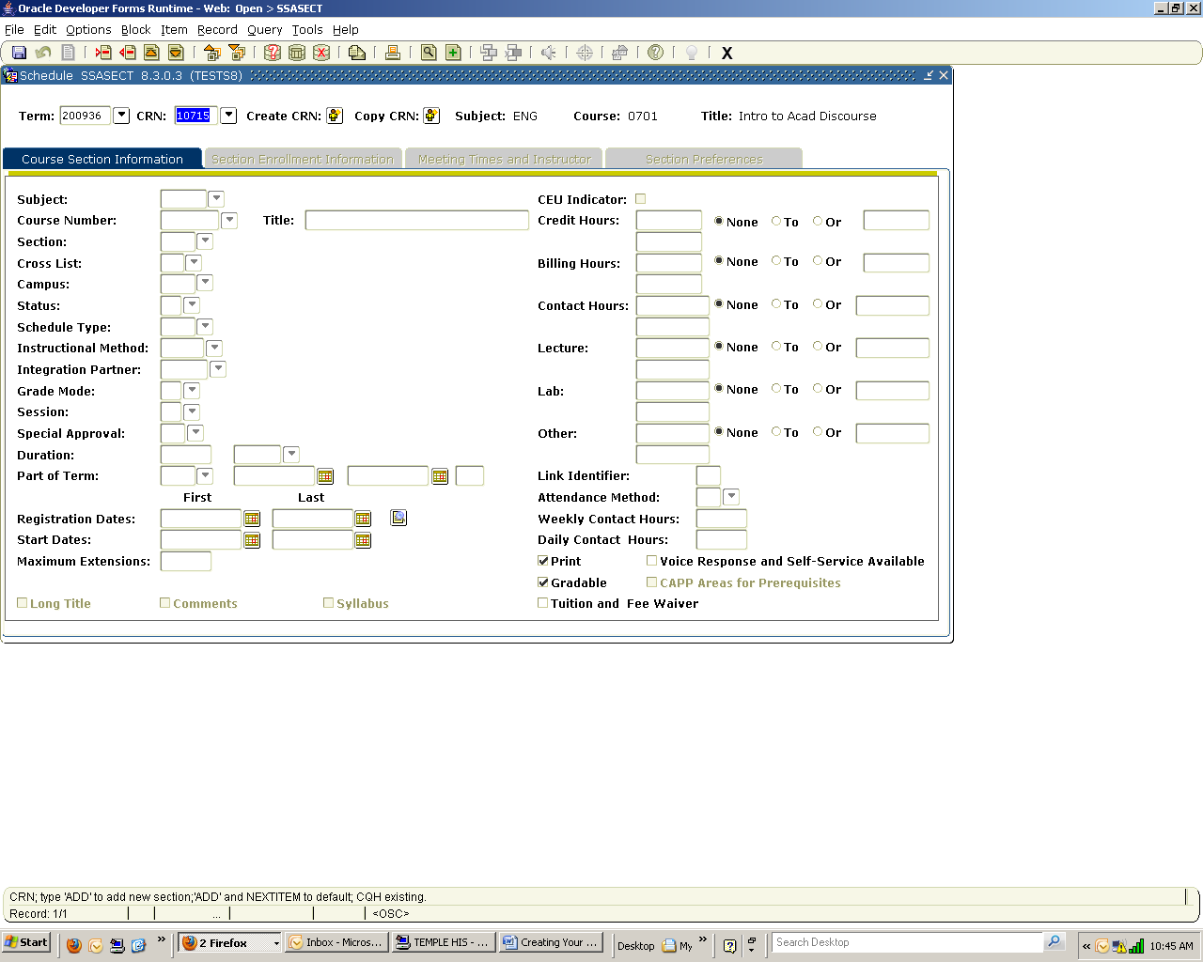

The Select icon (third from the left) is used to return data to the functional form from a query form. It becomes active when it is red. We’ll see this demonstrated in SSASECT.

There are three basic ways to access Banner forms.

- Enter the form name into the menu window.
  - If the form name is not known, enter a portion of the name or description using the wildcard symbol (%).
  - For example, to access SSASYLB, Section Syllabus, use SSASY% or %Syllabus

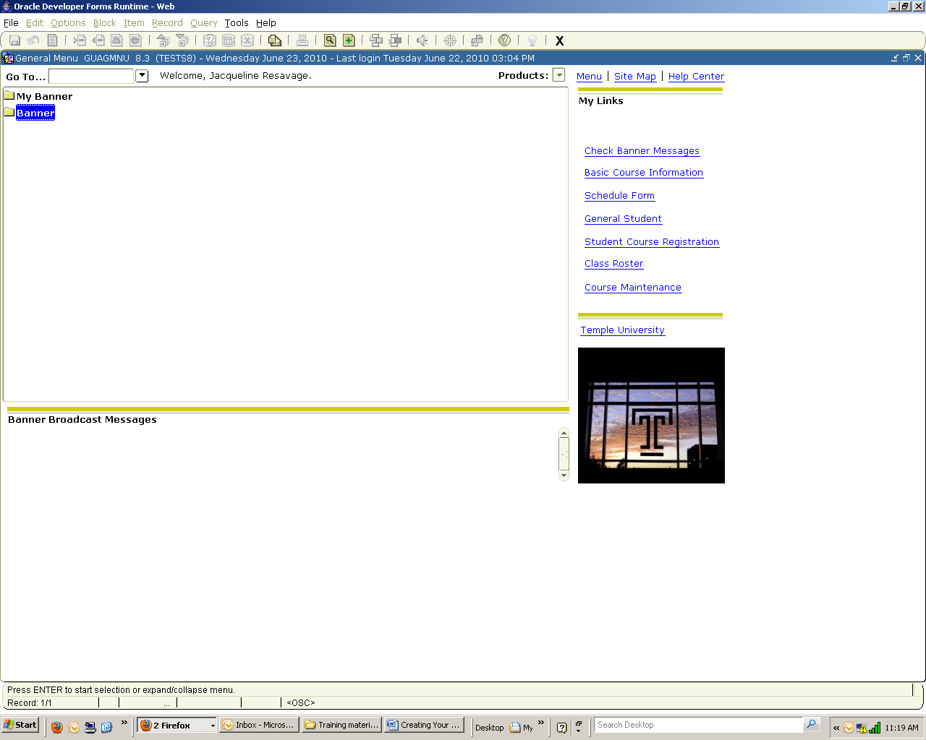

- Select the name from the Banner Menu page.
  - Double click on Banner.
  - Double Click on the desired Student application, like Catalog or Schedule.

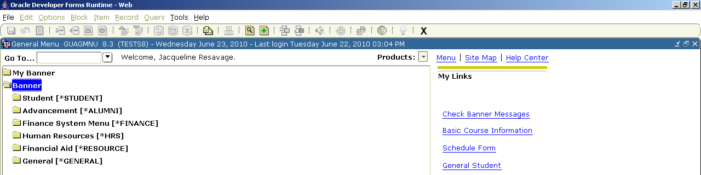

  - Double Click on the appropriate form.

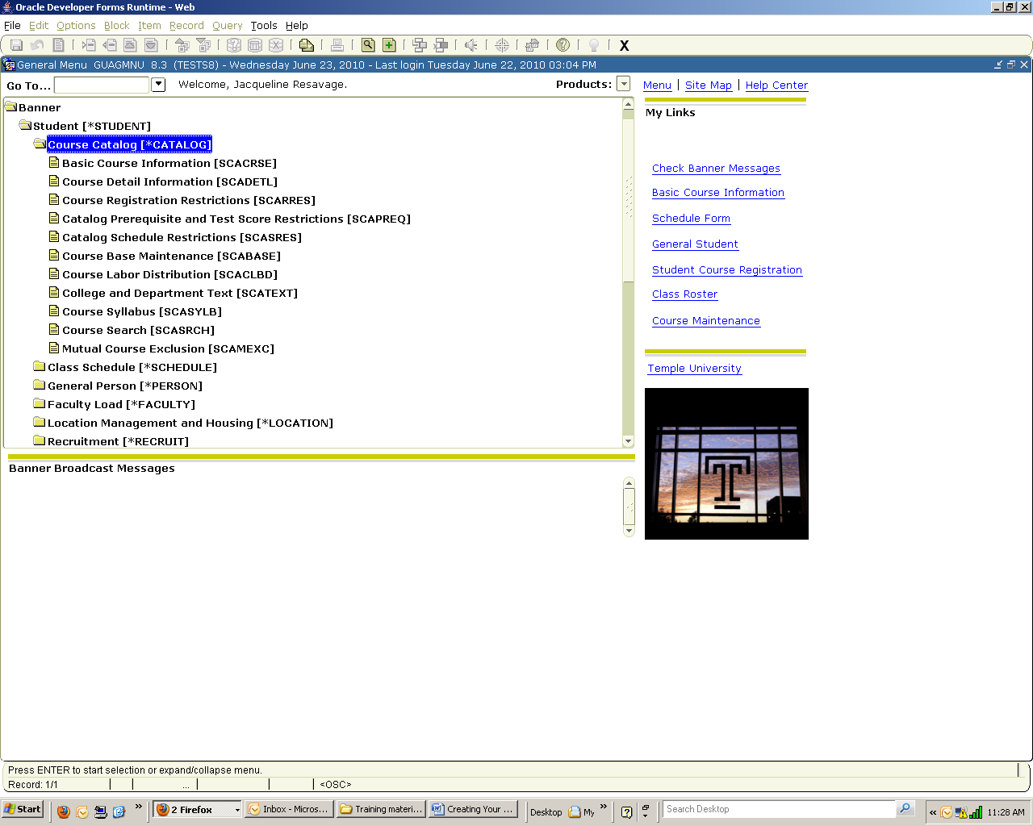

- When viewing the primary form in an application, like SCACRSE or SSASECT, you may select a related form from Options on the Menu Bar.

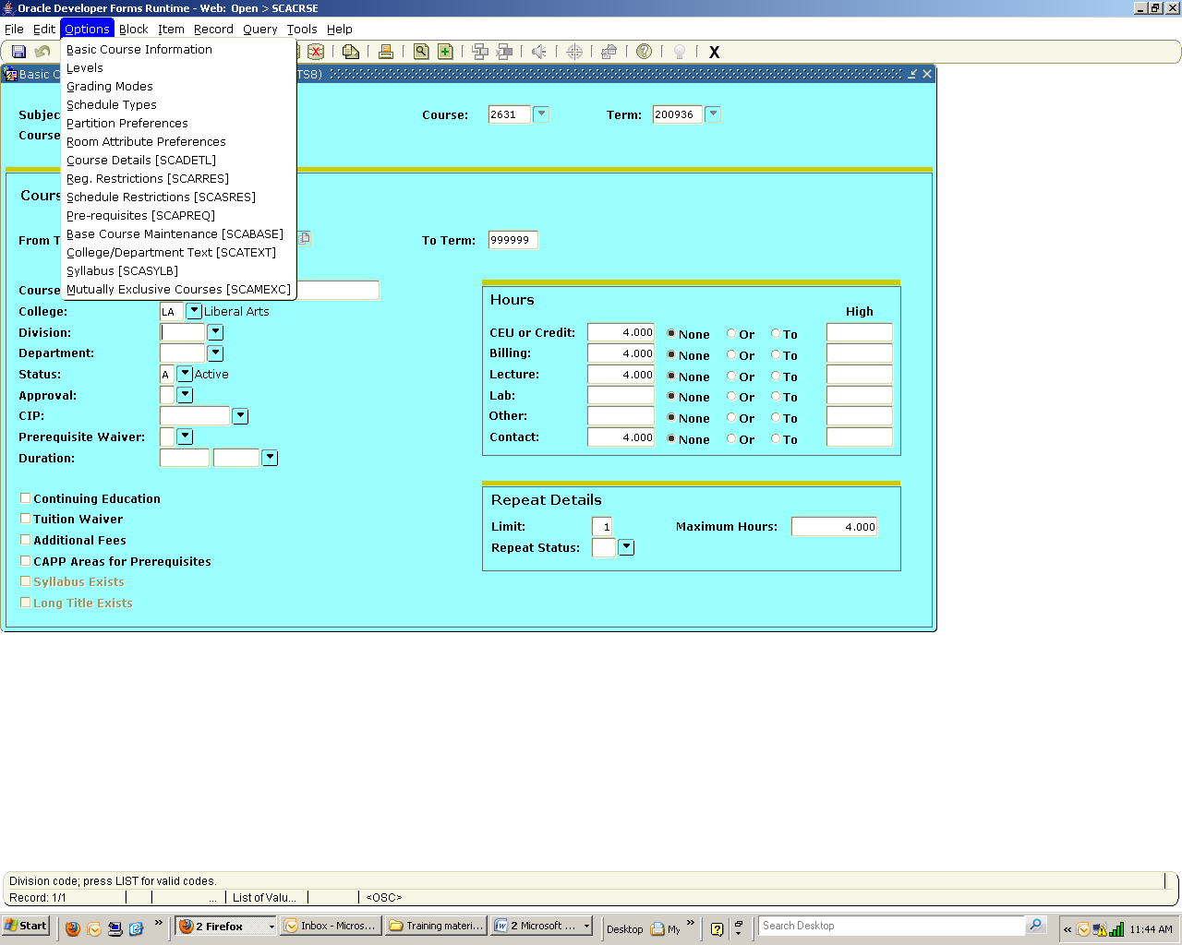

Basic Scheduling Data Entry

Scheduling a Section of a Course
Purpose
- The Schedule Form (SSASECT) is used to build and maintain the schedule of classes. A course catalog record (SCACRSE) must exist prior to the creation of sections for a particular course as well as the term controls defined on the Term Control Form (SOATERM). This is the form where required and other basic section demographics are entered – campus, schedule type, Part of Term, maximum seats day, times, instructors.
- During the scheduling process it’s not always known who will be teaching all sections. A Faculty Load form, Faculty Assignment (SIAASGN), is an easy way to add CRNs to an instructor ID once this information is determined.
- The Integration Partner field in the Section Details block in the main window is for use with integration processing, and is currently applicable to Blackboard only. When entering data in SSASECT, Blackboard will automatically display as the default from the Course form.
- Sections of a course can be scheduled either by opening one from a rolled term or adding a new section into a term.
Banner form
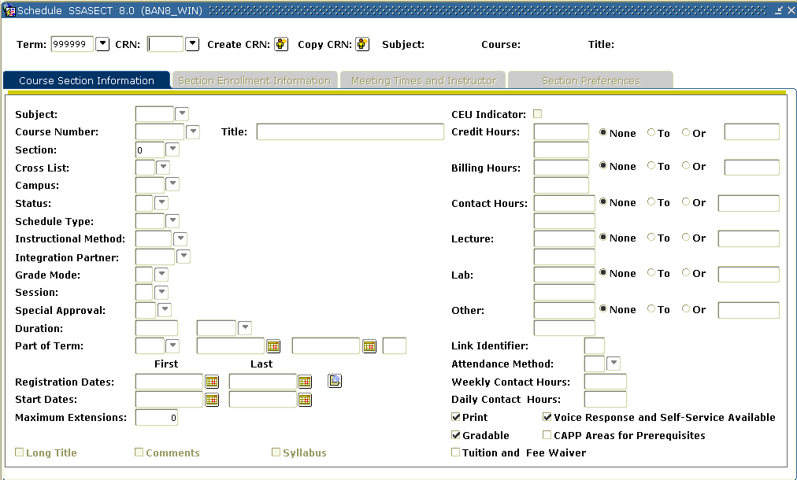
Checks
- Print (default) – Allows the display of the section in a printed class schedule.
- Voice Response and Self-Service Available (default) – Allows display of the section in the SSB Class Schedule
- Gradable (default) – Permits grades to be assigned to the section. Appropriate for all sections but the few 0.0 credit RECs and LABs using the same course number as the credit bearing Base.
- CAPP Areas for Prerequisites – This check will be applied from an entry made on a pre-requisite form.
- Tuition and Fee Waiver - Adding a campus of JPN (Japan) will trigger this check since assessments are not done for students on this campus.
Note:
- Adding a status is dependent on the role of the scheduler. Some will only be able to select “Propose”, some “Open” and others may select “Active”.
  - A section with a Meeting Time must have a room assignment before the status may be changed to Active.
  - Only sections with Active status can be published in the Course Schedule.

- Blackboard will default as the Integration Partner.

Overview – Opening a section rolled into a term
Steps
Select a section from your Subject list and open it in the term 200936.
Follow these steps to complete the process.

- Access the Schedule Form (SSASECT).
- Enter the term in the Term field.
- Click the down arrow in the CRN field to access the Schedule Section Query form (SSASECQ).
- Click in the Subject field on SSASECQ and use the down arrow to select your subject code.
- Enter the Status R.
- Click F8 for a list of rolled sections in the term.
- Scroll down to select the desired section and Click on the highlighted Select icon to return to SSASECT.
- Change the Status from R to A.
- Click the Save icon.
- Click the Exit icon.

Overview – Adding a new section to a term
Steps
Select a course from your Catalog and create a course section of it in the term 200936.
Follow these steps to complete the process.

- Access the Schedule Form (SSASECT).
- Enter the term in the Term field.
- Enter ADD in the CRN field.
- Perform a Next Block function.
- In the Subject field use the down arrow to “View Existing Courses”. Enter data in the “Find” window to go directly to your preferred subject code.
- Select the Subject and Course for which you will be adding a section.
- Continue by entering the following information.

Field | Enter | Value
Section | 1 | 1
Campus | AMB, MN or HSC | Ambler, Main, Health Science Center
Status | A | Active
Schedule Type | BAS | Base Lecture
Part of Term | 1 | 1
Part of Term Date | Tab | From/To Dates

- Click the Save icon.
Result: A CRN has been assigned to the section.
- Click the Exit icon.
Note: If a grade mode is selected from a list of more than one, students will be unable to change grade mode for that section during registration. If this field is left blank, students can request one of the grades modes set at the catalog level.
Assigning Enrollment Information
Purpose
The Section Enrollment Information window of the Schedule Form (SSASECT) is used to build and maintain the enrollment and reserved seat information associated with this class section.
Enrollment Details tab

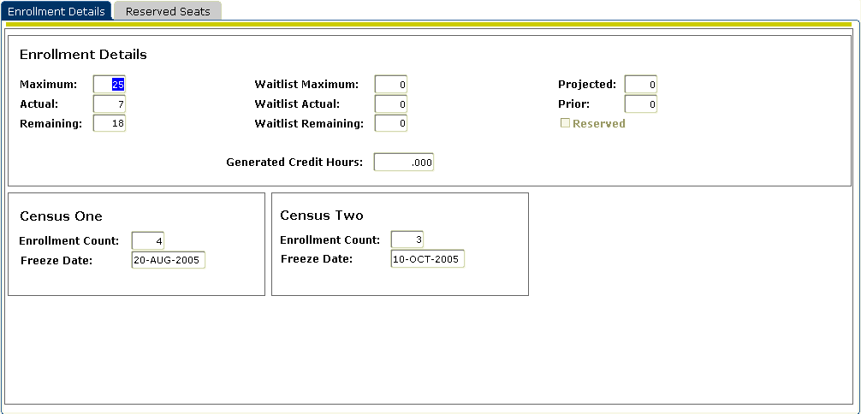

Steps
Use the course section created in the previous exercise.
Follow these steps to complete the process.

- Access the Schedule Form (SSASECT).
- Enter the term in the Term field.
- Enter the CRN assigned to the course in a previous lesson in the CRN field.
- Click the Next Block icon or click on the Section Enrollment Information tab.
- Change the enrollment maximum for the section in the Maximum field.
- The Projected and Prior fields are not required, but can be used for reporting purposes. Populate the Projected field, if desired. The Prior field will be populated if the section was rolled from a prior term.
Note: the Actual, Remaining, Generated Credit Hours, and Census One and Two Enrollment Count fields will be populated with values as registration processing occurs over time.
- Click the Save icon.

Reserving Seats
Purpose
The Enrollment Data window of the Schedule Form (SSASECT) is used in this exercise to reserve seats, using the Reserved Seats tab.
Note: Reserved seating functionality assumes that at least one seat is NOT reserved.
Banner form
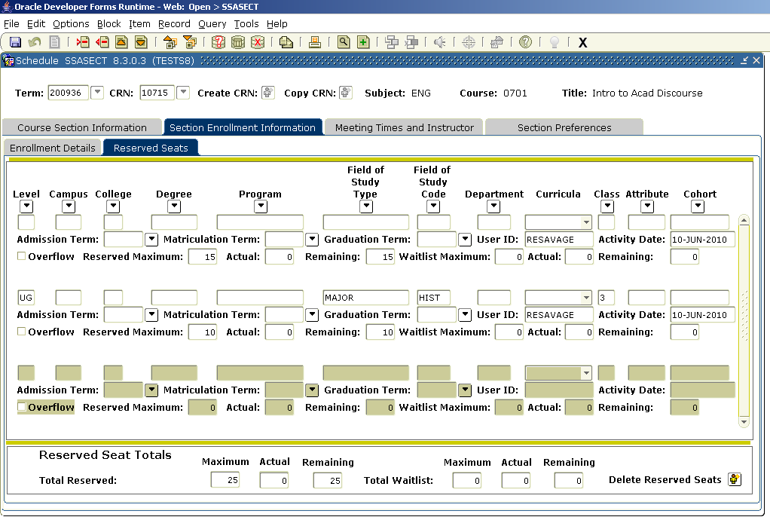

Steps
Ten seats in a 25 seat section need to be reserved for undergraduate, junior history majors.
Follow these steps to complete the process.

- Access the Schedule Form (SSASECT).
- Enter the term in the Term field.
- Enter the course reference number from the previous exercise in the CRN field.
- Click the Next Block icon.
- Click the Section Enrollment Information tab.
- Click the Reserved Seats tab.
- Enter this information in the window.

 | Level | Major | Class | Maximum Seats
1st row |  |  |  | 15
2nd row | Undergrad | History | JR | 10

- Check Overflow in the row where seats have been reserved.
- Click the Save icon.
- Click the Exit icon.

Note:
- The maximum number of seats in a section is the total of reserved maximum in the top section of the form and the reserved maximums entered in the remaining sections of the form.
- Checking “Overflow” will allow the students who meet the reserved criteria to register for any remaining vacancies after their reserved seats have been filled. Leaving the field unchecked will prohibit the population from registering for any more seats than the number reserved for them.

Assigning Meeting Times, Rooms & Instructors
Purpose
The Meeting Times window of the Schedule Form (SSASECT) is used to build and maintain day and time information in the schedule of classes.
Note:
- An entry from the Meeting Time Code Validation table (STVMEET) is required for all Day & Evening Undergraduate BASE courses on Main campus. This table is accessed by clicking the down arrow in the Meeting Time field. The entries on this table reflect the University’s approved Undergraduate Day and Evening class matrix for Main Campus. Exceptions must be requested though a Workflow process.
- For all other sections days and times may be entered manually. However, this table is a way of facilitating the entry of the on matrix days of the week and the start and end times for each record in the meeting time block.
Times and Instructors window
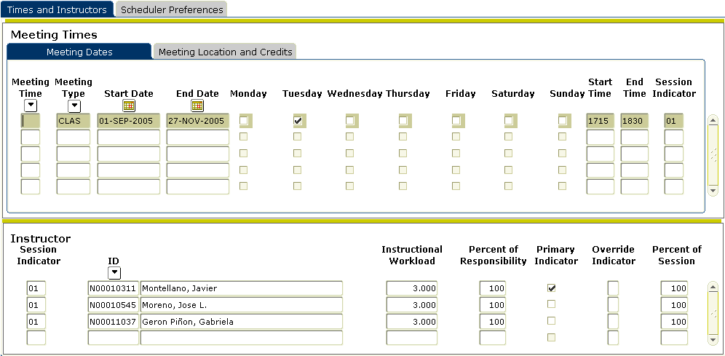

Steps – Meeting Dates
Using the meeting times table, assign a meeting time, location, and an instructor to the History of Civilization course section that was scheduled in the previous exercise.
Follow these steps to complete the process.

- Access the Schedule Form (SSASECT).
- Enter the term in the Term field.
- Enter the CRN assigned to the course in a previous lesson in the CRN field.
- Select Scheduled Meeting Times from the Options menu or click on the Meeting Times and Instructor tab. You can also perform a Next Block function to navigate to this block.
- For all Day & Evening Undergraduate BASE courses on Main campus click the down arrow below the Meeting Time field to access the Meeting Time Code Validation Form (STVMEET).
Note: A table entry must be selected for this category of courses.
- Select a meeting time by double-clicking a value or highlighting the desired code and clicking on the Red Select icon (third from the left).
- For all other courses (undergraduate courses not on Main campus, graduate and professional level courses) days and times may be entered manually or selected from the table.
Note: Multiple session types can be used to distinguish the different purposes of meeting times, e.g. base lecture, lab, recitation, studio, etc.
- Click the Save icon.

Steps - Instructor
- Perform a Next Block function to navigate to the Instructor window.
- Enter the ID of the instructor assigned to the class.
- Enter the percent of responsibility in the Percent of Responsibility field. For this exercise, use 100. Note: An override check is required if the instructor chosen has been entered on a section with a conflicting time.
- Click the Primary checkbox to identify the person as the primary instructor.
- Click the Save icon.
- Click the Exit icon.
When the faculty ID is not known, follow the steps below to add instructors using the Faculty/Advisor Query Form (SIAIQRY).

Steps – Rooms
Separate R25 training classes are available to classroom and event schedulers. R25 access is needed for the entry of Building codes and Room numbers into the Banner schedule.

Faculty/Advisor Query Form
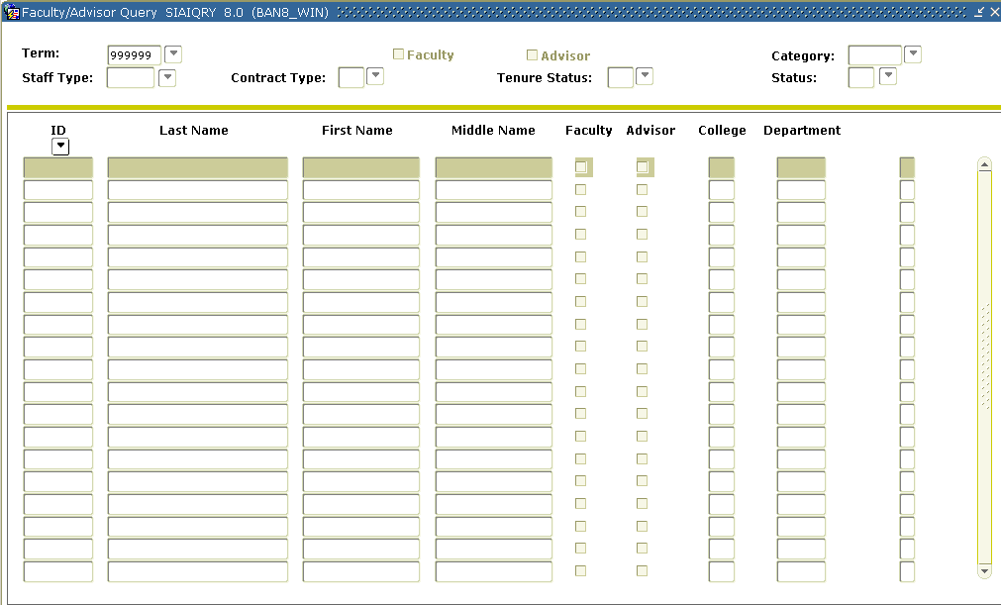
Steps

- Navigate to the Instructor window in SSASECT.
- Click the down arrow below ID to access the Faculty/Advisor Query Form (SIAIQRY).
- Perform the Next Block function and enter the instructor’s name (this field is case sensitive) and other data related data and click F8 to begin the search.
Note: If the entire name is not known enter as much as possible using the wildcard feature (%). For example, entering John% would produce the names John, Johns, Johnson and Johnston.
- Locate the faculty member. Select a Faculty member's ID. Use the Select icon to return to SSASECT with the faculty member's name and information.
- You may also enter specific information about the faculty member (such as the category, staff type, college, etc.) to assist in your search.
- Enter the percent of responsibility in the Percent of Responsibility field. For this exercise, use 100. Note: An override check is required if the instructor chosen has been entered on a section with a conflicting time.
- Click the Primary checkbox to identify the person as the primary instructor.
- Click the Save icon.
- Click the Exit icon
Assigning Sections to an Instructor
Purpose
The Faculty Assignment form (SIAASGN) is used add CRNs to an Instructor’s record. This is convenient alternative to adding an instructor to multiple CRNs.
Banner form
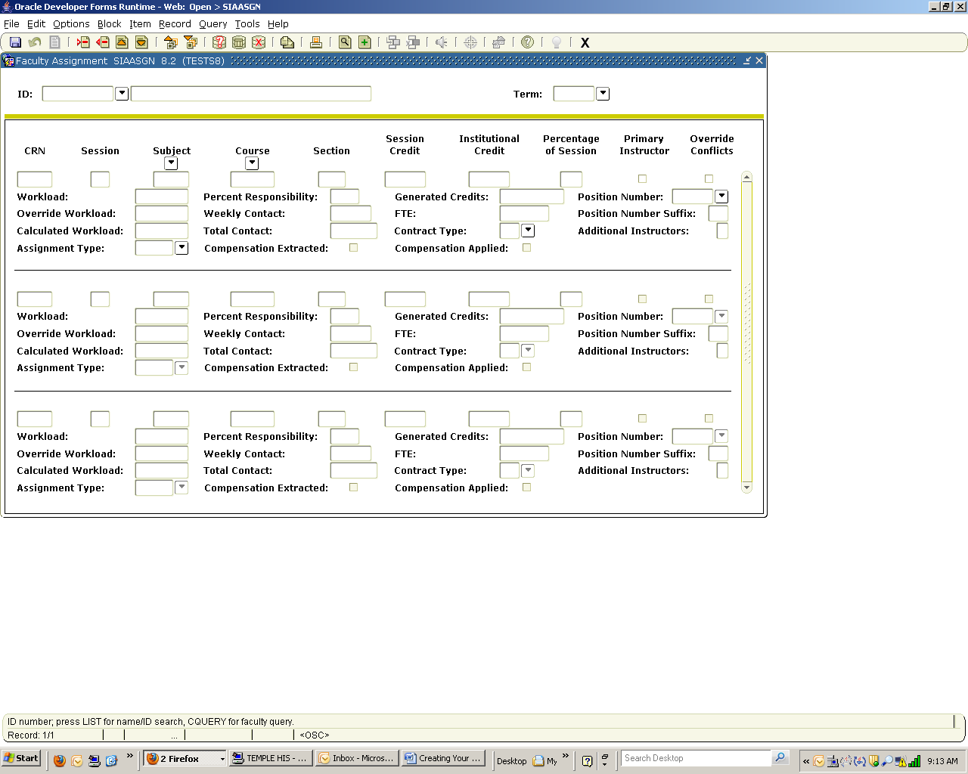

Steps
- Access the Faculty Assignment form (SIAASGN).
- Enter the ID of the faculty for whom you want to assign sections or follow steps 1 - 4 in the Faculty/Advisor Query Form section above to select the instructor ID.
- Enter Term.
- Perform a Next Block function.
- Enter the appropriate CRN in and press Enter.
- Enter the next CRN in the area below.
Note: Once the form has filled you can obtain a blank space using the Record Insert icon (fourth from the left) or selecting Insert from Record menu at the top of the form.
- Click on the Save icon.
- Click on the Exit icon.

Creating Multiple Sections of a Course
Purpose
The Schedule Form (SSASECT) is used in this exercise to create multiple sections of a course.
Banner form

Overview
Create three sections of a course from your catalog.
Table 1
Use the information in Table 1 to complete the procedure that follows. If necessary, refer to page 10 for individual Steps.

Field | Enter | Value
Subject/Course | Select from View Existing Courses
Section | 1 | 1
Campus | AMB, MN or HSC | Ambler, Main, Health Science Center
Status | A | Active
Schedule Type | BAS | Base Lecture
Part of Term | 1 | 1
Save | Click on Save icon | 1 record applied and saved
Remember to write down the CRN generated for this section!
Steps
Follow these steps to complete the process of adding two more sections of the course.
- Rollback to Access a blank Schedule Form (SSASECT).
- Click the Copy CRN icon.
Result: The Default Section Details window will appear.
- Populate the Default Course Ref. Number with the CRN that you want to copy (the one you previously created above).
- Press the Enter key, which will activate the Process Default button.
- Tab to the Section field and change the section number to 2.
- Click the Save icon.
- Click the Rollback icon to return to the key block.
- Type ADD in the CRN field
- Click the Copy CRN icon.
Result: The Default Section Details window will appear Use the same default
- Populate the Default Course Ref. Number with the CRN that you want to copy (the first one or the last one you created above).
- Press the Enter key, which will activate the Process Default button.
- Tab to the Section field and change the section number to 3.
- Click the Save icon.
- Click the Exit icon.

Overview – Multiple Schedule Types
Create three sections of a course with multiple schedule types – a Base, a Lab and a Recitation.
Table 1
Use Tables 1 & 2 below to create the Lecture section. See page 10 for the individual Steps.

Field | Enter | Value
Subject | Phys | Physics
Course | 1132 | 1132
Section | 1 | 1
Campus | MN | Main
Status | A | Active
Schedule Type | BAS | Base Lecture
Part of Term | 1 | 1
Table 2
Use the information in Table 2 to complete the procedure that follows, then click on Save.

Field | Low | To/Or | High
CEU/Cred(it) | 0.00 | OR | 4.00
 | 4.00
Billing | 0.00 | OR | 4.00
 | 4.00
Contact | 0.00 | OR | 4.00
 | 4.00 (default)
Table 3
Use the information in Table 3 to create the Lab and Recitation sections.

Field | Enter | Value
Section | 2 (lab section)  3 (recitation section)* | 2  3
Campus | MN | Main
Status | A | Active
Schedule Type | LAB  REC* | Lab  Recitation
Part of Term | 1 | 1

*Repeat the steps in Table 3 to create a recitation section, using section number 3 and schedule type REC.
Table 4
Use the information in Table 4 to complete the procedure that follows.

Field | Low | To/Or | High
CEU/Cred(it) | 0.00 | OR | 4.00
 | 0.00
Billing | 0.00 | OR | 4.00
 | 0.00
Contact | 0.00 | OR | 4.00
 | 0.00 (default)

Note: Courses requiring multiple Schedule Types will be defined in the Course Catalog as variable credit. Based on current practice, the 0.00 in the lower limit is reserved for the Lab or Recitation type. The upper limit will contain the credit value for the Base Lecture.

Steps
Follow these steps to complete the processes for sections 2 & 3 outlined in Tables 3 & 4.

- Rollback to access the Schedule Form (SSASECT).
- Click the Copy CRN icon.
Result: The Default Section Details window will appear.
- Populate the Default Course Ref. Number with the CRN that you want to copy (the one you just created above).
- Press the Enter key, which will activate the Process Default button.
- Tab to the Section field and change the section number to 2.
- Perform a Next Block function.
- Enter the information from Tables 3 and 4 into the appropriate fields to create the lab section for the course.
- Click the Save icon.
- Click the Rollback icon to return to the key block.
- Type ADD in the CRN field
- Click the Copy CRN icon.
Result: The Default Section Details window will appear Use the same default
- Use the same process as above to create the recitation section (section 3).
- Perform a Next Block function.
- Enter the information from Tables 3 and 4 into the appropriate fields to create recitation section for the course.
- Click the Save icon.
- Click the Exit icon.
Special Scheduling Data Forms
Adding Specialized Features to Sections
Purpose
- Properties like registration restrictions at the course level entered on SCARRES respectively default to sections that are rolled or added after these course data have been populated. This form is centrally maintained.
- Schedulers can add or revise registration restrictions for specific sections on the Schedule Restrictions form (SSARRES).
- Course syllabus entries on SCASYLB don’t default automatically to sections but can easily been brought into sections on the Section Syllabus form (SSASYLB) by clicking on the highlighted a “Copy from Course” icon. Data that must differ from the course level can also be entered directly on SSASYLB.
- Another form that adds data of a special nature to sections is the Section Comment (SSATEXT) form. Data entered here will appear on the Course Schedule in SSB.
- The Cross List (SSAXLST) form and the Block Schedule (SSABLCK) form are used to join sets of sections for specific registration purposes.

Registration Restrictions at the Schedule Level
Purpose
The Schedule Restrictions form (SSARRES) is used revise the catalog level restrictions.
Banner form
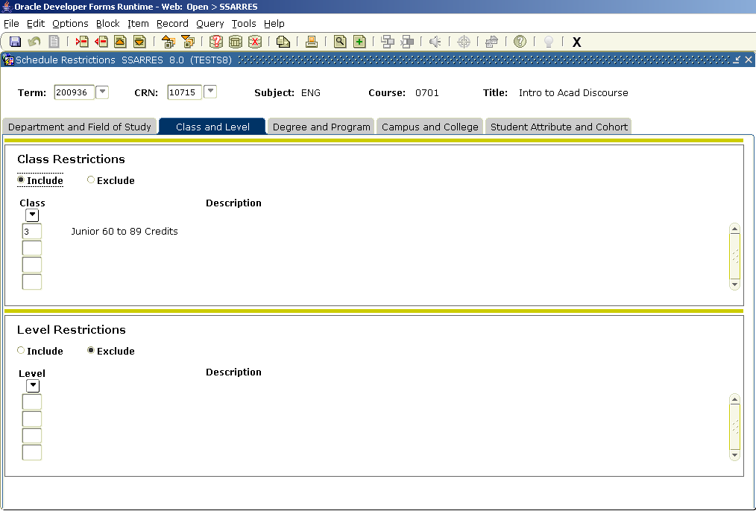
Steps
This section has class level registration restrictions entered on the Catalog level that defaulted to the Schedule level. However, this section should restrict only freshmen.
Follow these steps to complete the process.

- Access the Schedule Restrictions Form (SSARRES).
- Enter the term in the Term field.
- Enter the Course Reference Number for this course in the CRN field. If you don’t know the CRN, refer to Steps 3-7 on page 13.
- Perform a Next Block function three times to navigate to the Class and Level section or perform Next Block once and click on the Class and Level Tab.
- Change the restriction from what displays to Exclude Class 1.
Note: This change will prevent students classified as freshmen from registering for this CRN without an override.
- Click the Save icon.
- Click the Exit icon.
Maintaining Section Syllabus Information
Overview
Use the optional Section Syllabus Form (SSASYLB) to enter/display a section’s Long Title, learning objectives, required materials, and technical requirements. This information is displayed on the Web to aid students in selecting and registering for courses. If more appropriate, course syllabus information from SCASYLB can be copied by clicking the hightlighted “Copy from Course” icon. If the icon is not highlighted, no data exists at the catalog level.
Banner form

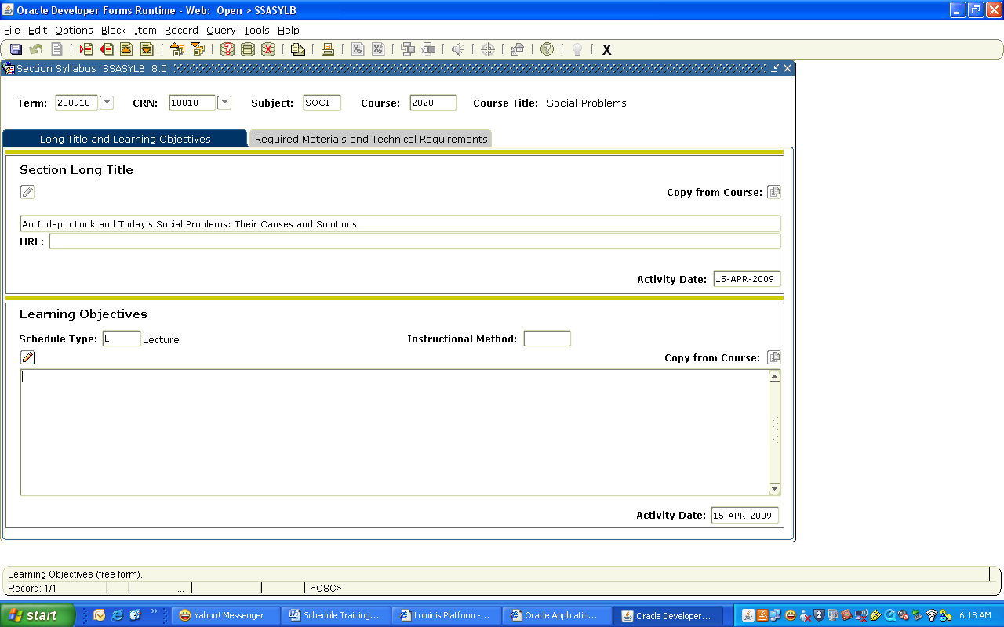

Steps
Follow these steps to complete the process.

- Access the Section Syllabus form (SSASYLB)
- Enter the term in the Term field and CRN in the key block
- Select the Next Block
- For each of the information blocks you may use the Copy from Course icon on the far right when highlighted to copy syllabus data from the catalog level (SCASYLB) or manually enter data specific to the section.
- Click the Save icon
- Click the Exit icon

Creating Section Comments
Overview
Use the Section Comment Form (SSATEXT) to enter or display comments associated with a section. Comments entered here appear may appear on the Class Schedule Report (SSRSECT) and in the Class Schedule in Self Service Banner. Note: Use only the Section Long Text area of the form.
Banner form

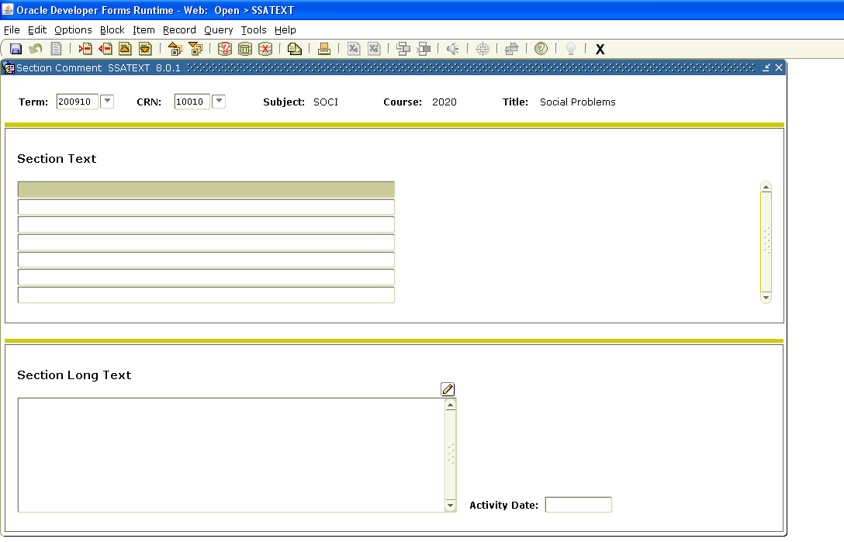

Steps
Follow these steps to complete the process.

- Access the Section Comment form (SSATEXT)
- Enter the term in the Term field and CRN in the key block
- Select the Next Block
- Enter the appropriate comment in the Section Long Text block.
- Click the Save icon
- Click the Exit icon

Cross Listing Sections
Introduction
Cross listing allows the institution to group courses with common meeting times and instructors that have the same course content, but differ by Subject and/or Course Number.
Cross listing is made possible by using a cross list group identifier which is centrally defined and distributed to the Schools and Colleges. Use the Schedule Cross List Definition Form (SSAXLST) to create and maintain the cross list codes associated with a group of sections. A cross list identifier must be established for the term on this form prior to being entered on the Schedule Form (SSASECT).
Banner form
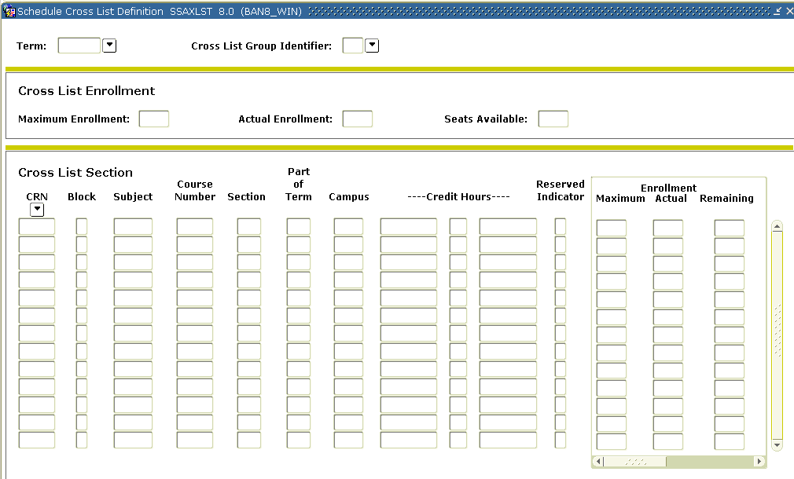

Steps: Exercise 1
In this exercise, we will create two sections from your departments. Follow these steps to complete the process.

- Access the Schedule From (SSASECT).
- Create two new sections.
- Click the Save icon.
- Click the Exit icon.
Steps: Exercise 2
In this exercise, we will cross-list sections. Follow these steps to complete the process.

- Access the Schedule Cross List Definition Form (SSAXLST).
- Create a new cross list identifier by typing an assigned two-digit code in the Cross List Group Identifier field.
- Perform a Next Block function.
- Set the maximum enrollment number for the cross-list in the Maximum Enrollment field.
- Perform a Next Block function.
- Enter two CRN numbers you created.
- Click the Save icon.
- Click the Exit icon.

Steps: Exercise 3
Verify that the cross-list identifier exists. Follow these steps to complete the process.

- Access the Schedule Form (SSASECT).
- Choose either of the courses you cross-listed.
- Perform a Next Block function.
Result: You will see that your cross-list identifier has been entered in the appropriate Cross-List field.

Creating Blocks

Purpose
The Block Schedule Control Form (SSABLCK) is used to create a set of sections related to a block code for a term.
This code is then assigned to a student on the General Student Form (SGASTDN) or the Student Course Registration Form (SFAREGS).
Banner form
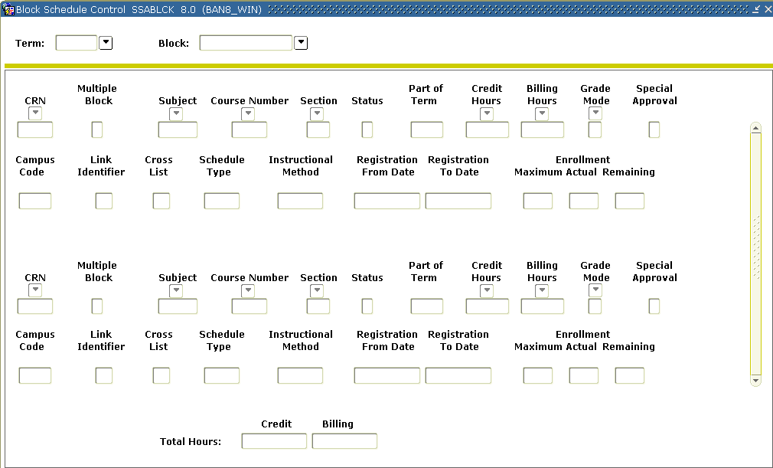

Steps
Follow these steps to complete the process.
Note: To complete this exercise, a code and description must be created on the centrally controlled Block Code Validation Form (STVBLCK).

- Access the Block Schedule Control Form (SSABLCK).
- Enter the term in the Term field.
- Enter the appropriate block code in the Block field.
- Perform a Next Block function.
- Enter the appropriate CRNs in the CRN field to attach the classes to the block.
- Click the Save icon.
- Click the Exit icon.

Query Only Scheduling Forms
Listing Sections in a Term
SSASECQ – Schedule Section Query

Allows query by any combination of the parameters shown on the form.
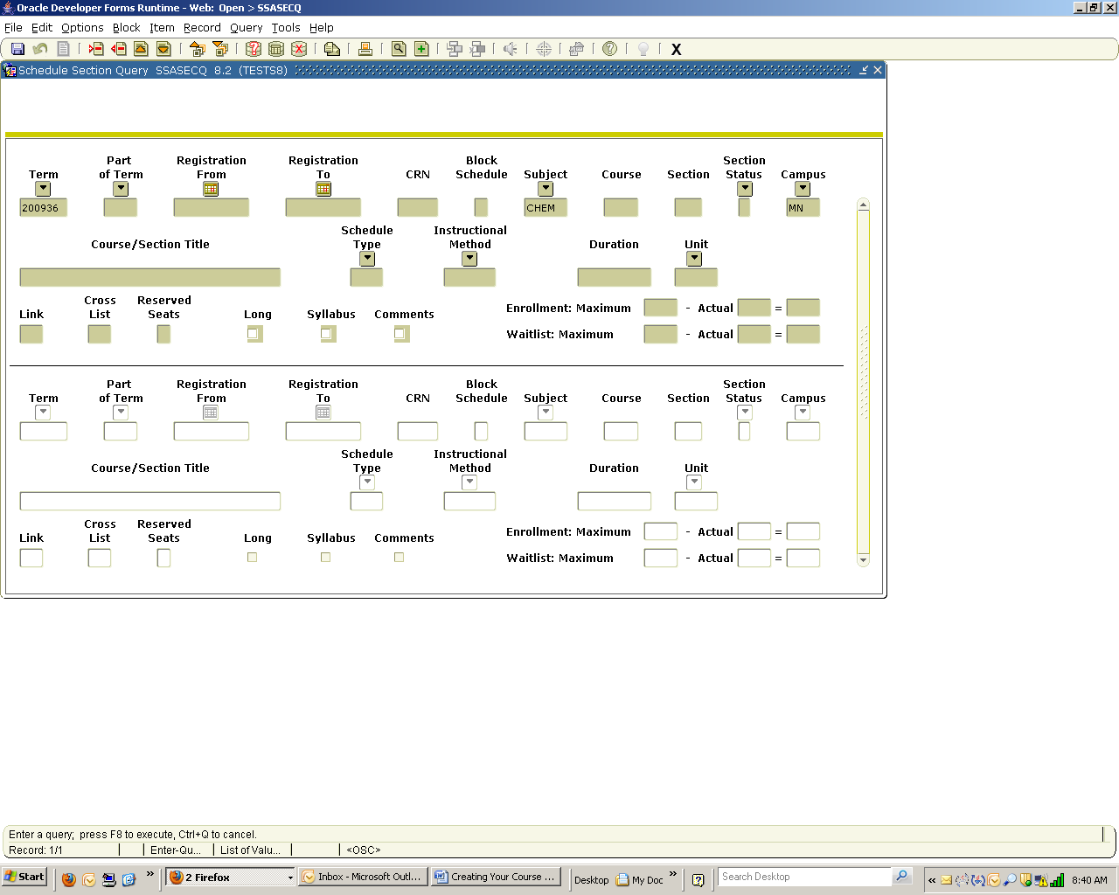
Listing Sections by Building and Room
SSAMATX – Building/Room Schedule

This form displays information about buildings/rooms scheduled for events, functions, and courses.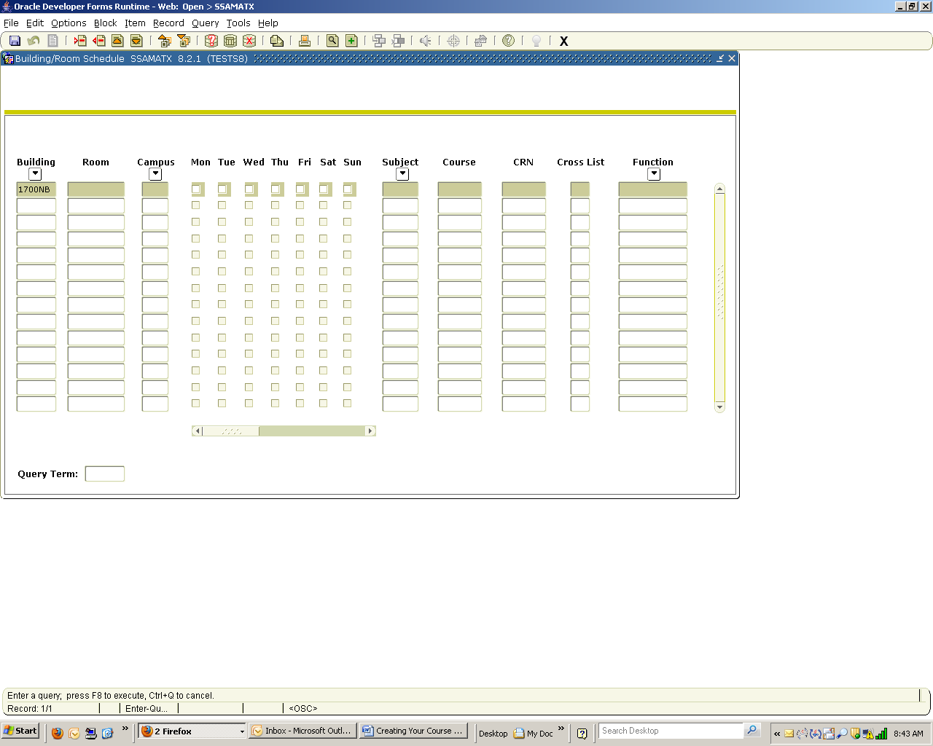
Listing Sections with Reserved Seating
SSIRESV – Reserved Seat Inquiry

Use this form to query and review reserved seats rules for a term and CRN combination.
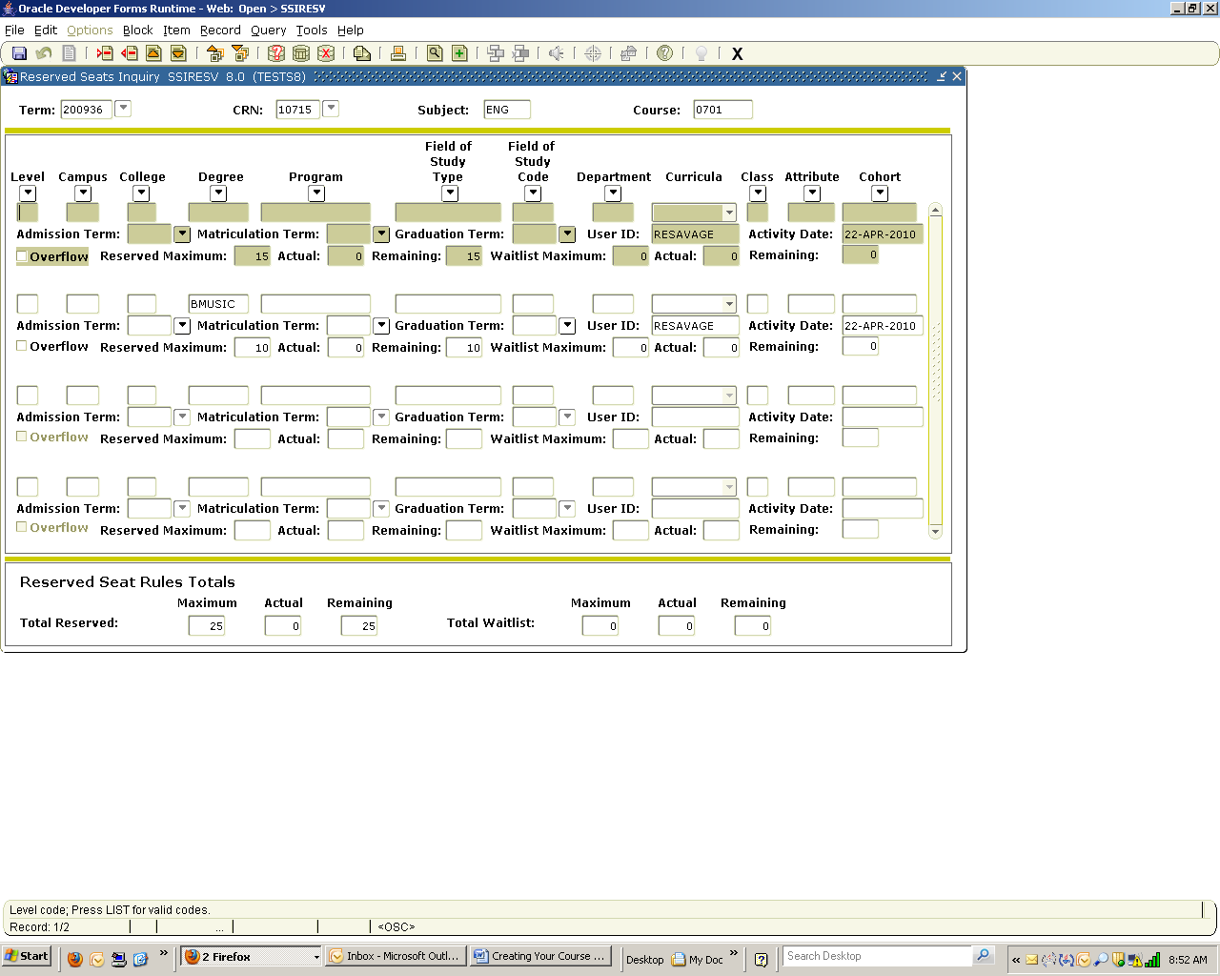

Listing Faculty Sections in a Term
SIAASGQ – Faculty Schedule Query

This form displays a faculty member’s schedule in a term. 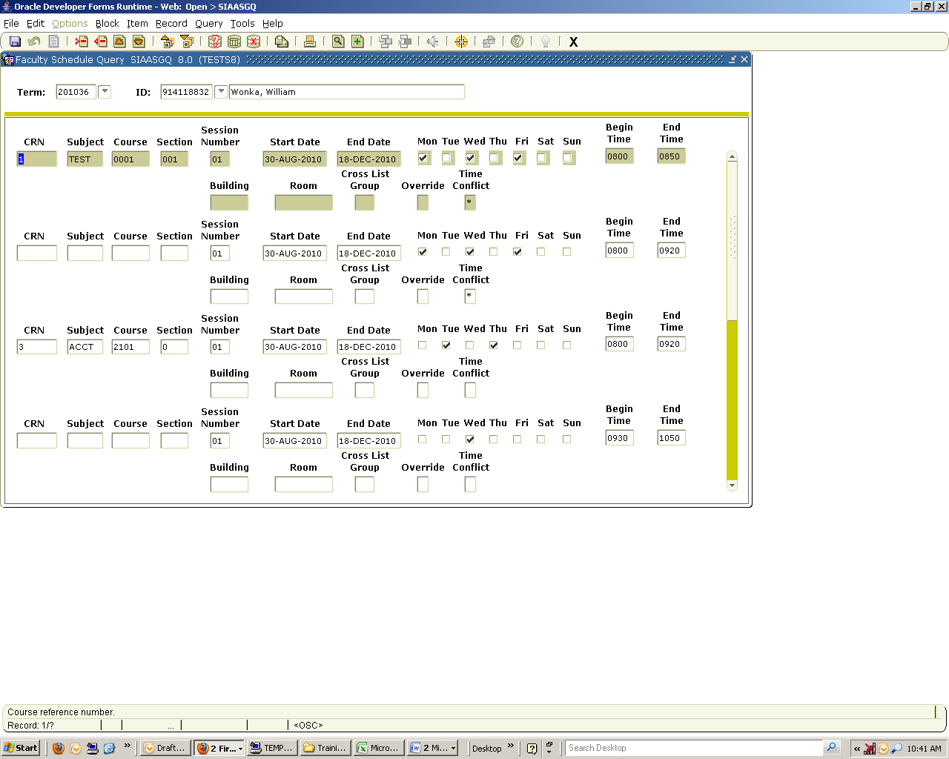
Listing Cross Listed Sections
SSAXLSQ – Schedule Cross List Query

This form displays all sections that have been cross-listed by term, or by a specific parameter or combination of parameters.
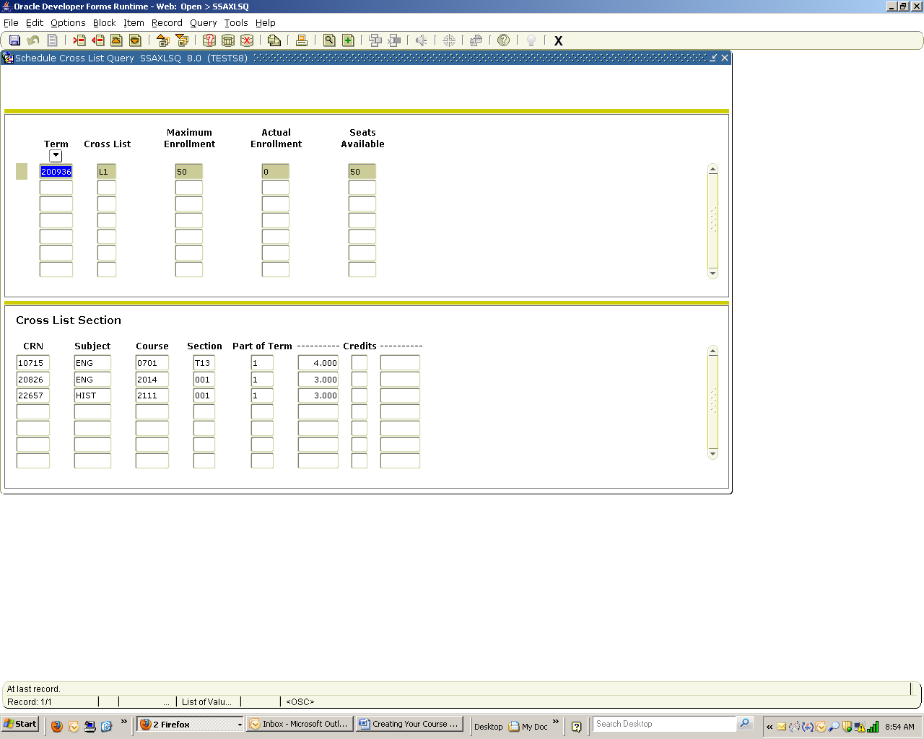
Listing Cross Listed Sections by Meeting Time
SSAXMTI – Cross List Meeting Time/Instructor Query
This form displays the meeting time and instructor information associated with a cross-listed group of courses by term and identifier. 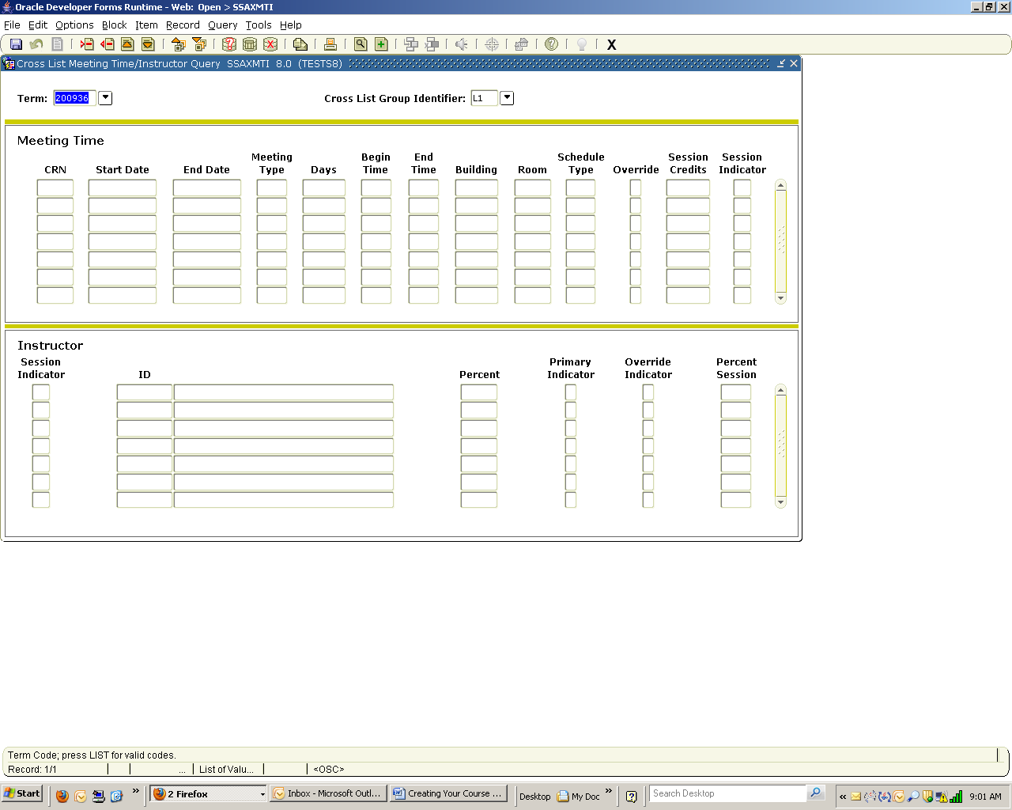
Listing Block Schedules in a Term
SSABLKQ – Block Schedule Query

This form displays all blocks in a term.
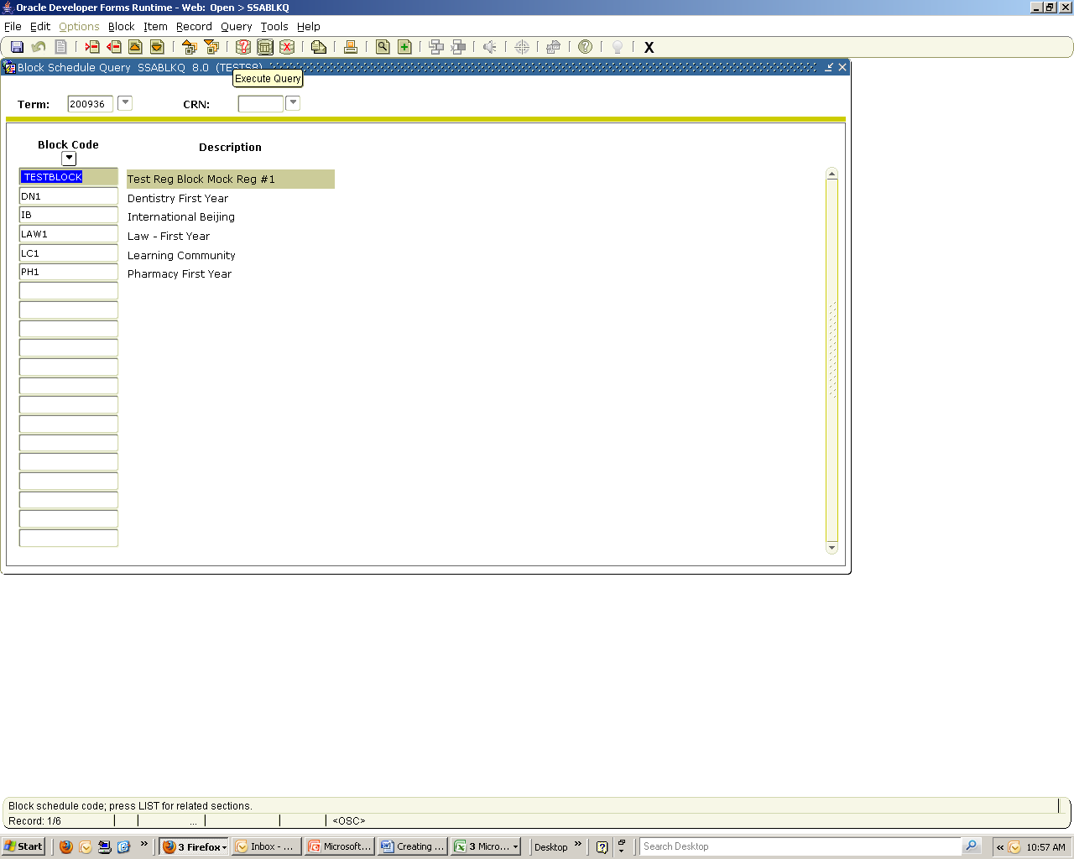
Listing Block Schedule Sections in a Term
SSABSCQ – Block Schedule Section Query

This form displays all sections in a block.
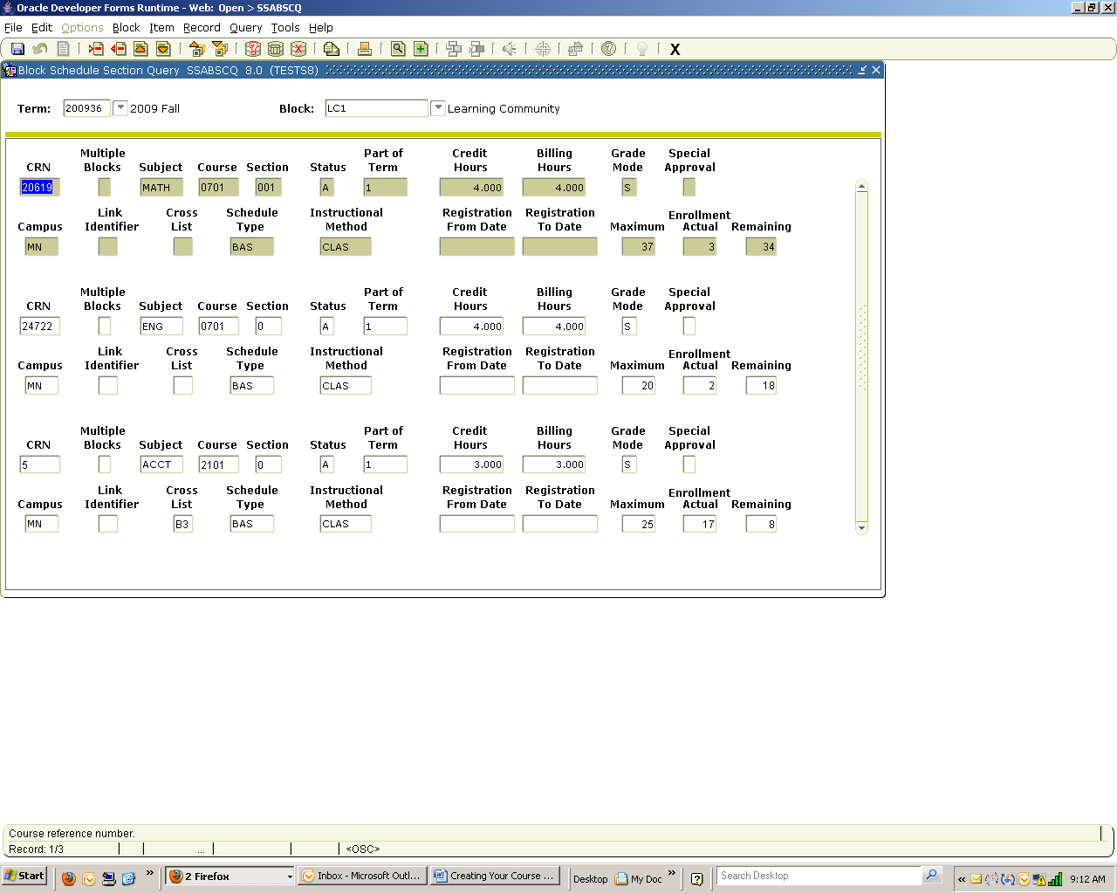

Self Service Banner (SSB) Class Schedule
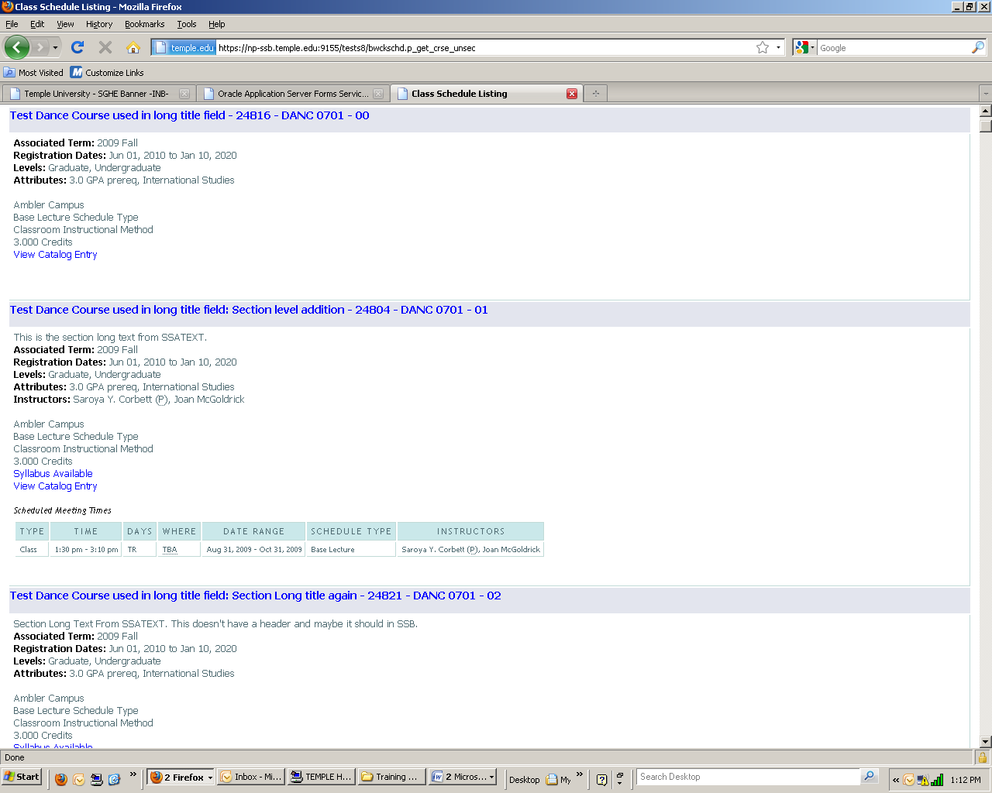

Note: Clicking on the Title will display capacity, pre-requisites, registration restrictions and fees, if applicable.

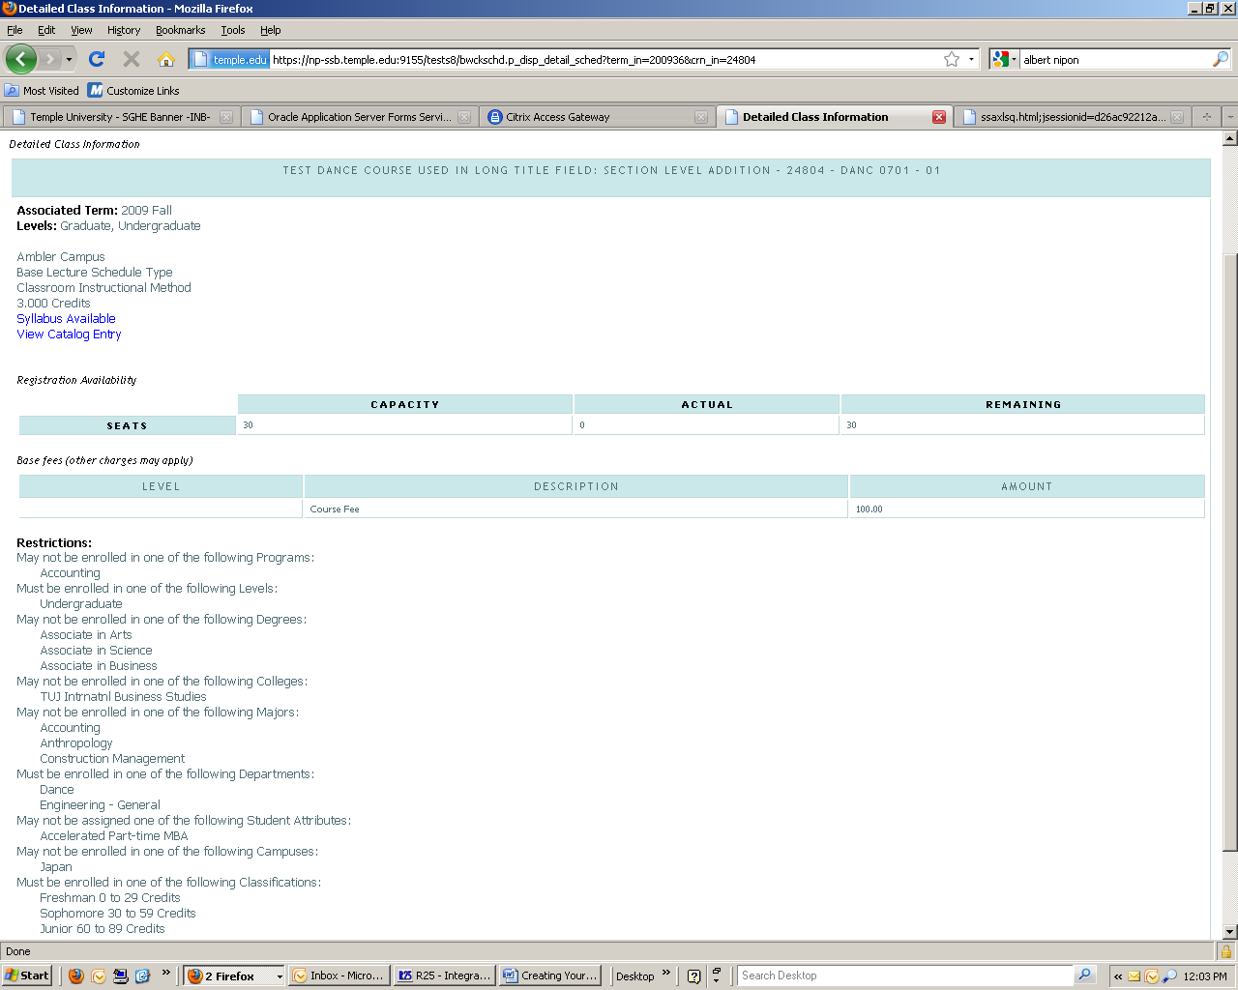

Summary

Let's review
As a result of completing this workbook, you have

- built and changed course sections
- assigned meeting times, locations, and instructors to sections
- created section comments
- established section syllabus
- cross-listed course sections
- created blocks
- accessed and reviewed query forms related to the Class Schedule module.

The appropriate personnel are now ready to build the sections and create the class schedule for your units.

Self Check
Directions
Use the information you have learned in this workbook to complete this self-check activity.
Question 1
Which form is used to schedule a course section for a term?

Which field do you double-click in to access a list of existing courses?

Question 2
Which form is used to assign a meeting time, location, and an instructor to a course section that was scheduled?

How do you access the Meeting Time window?

Question 3
Which form is used to search for a faculty member to assign as an instructor for this scheduled course section?

Question 4
Which form do you access to reserve seats for this course?
How do you access the Reserved Seating window?

Question 5
Which form is used to view or change restrictions that were entered on the Catalog level?

Question 6

Which form is used to add section comments?

Which form is used to view or change Long Titles and requirements entered on the Catalog level?

Question 7
Which form is used to create multiple sections of a course?

When performing a Rollback function to create an additional section, what will remain the same?

Question 8
What form is used to create cross list codes?

Answer Key for Self Check
Question 1
Which form is used to schedule a course section for a term?
The Schedule Form (SSASECT).
Which field do you double-click in to access a list of existing courses?
The Subject field.
Question 2
Which form is used to assign a meeting time, location, and an instructor to a course section that was scheduled?
The Schedule Form (SSASECT).
How do you access the Meeting Time window?
Select the Meeting Times and Instructor Tab from SSASECT.
Question 3
Which form is used to search for a faculty member to assign as an instructor for this scheduled course section?
The Faculty/Advisory Query Form (SIAIQRY).
Question 4
Which form do you access to reserve seats for this course?
The Schedule Form (SSASECT).
How do you access the Reserved Seating window?
You must select the Section Enrollment Information Tab/Reserved Seats Tab to access the Reserved Seating window.

Question 5
Which form is used to view or change restrictions that were entered on the Catalog level?
The Schedule Restrictions Form (SSARRES).
Question 6
Which form is used to add section comments?
The Section Comment Form (SCATEXT).
Which form is used to view or change Long Titles and requirements entered on the Catalog level?
The Section Syllabus Form (SCASYLB).
Question 7
Which form is used to create multiple sections of a course?
The Schedule Form (SSASECT).
When performing a Rollback function to create an additional section, what will remain the same?
The Term will remain the same.
Question 8
What form is used to create cross list codes?
The Schedule Cross List Definition Form (SSAXLST).
Appendix

Forms Job Aid
Form | Full Name |  | Use this Form to...
Validation
GTVINSM | Instructional Method Validation Form | create and maintain instructional method codes.
GTVMTYP | Meeting Type Validation | create and maintain meeting type codes.
STVACCL | Academic Calendar Type Validation | create, update, insert, and delete codes for academic calendar types, such as Daily Contact, Weekly Contact, or Continuing Education. This form is used by the Schedule Academic Calendar Form (SSAACCL) to validate academic calendar type codes. You can create and update these codes only from this form.
STVACCT | Attendance Accounting Method Validation | create, update, insert, and delete codes for the attendance accounting methods to be associated with course sections, such as Telecourses, Independent Study, or Weekly.
STVATRA - STVATRE | Day Attribute One through Day Five Validation | create, update, insert, and delete day attribute codes specific to an institution's needs for state or local reporting, for information required about a day for a particular year on a specific campus.
STVATTR | Attribute Validation | create, update, insert, and delete degree program codes, such as Affiliated Teaching Requirement, Language Requirement, or Writing Intensive Requirement.
STVBLCK | Block Code Validation | create, update, insert, and delete block codes which are used in Block Scheduling processing.
STVBLDG | Building Code Validation | create, update, insert, and delete building codes such as Biology Building, Gymnasium, or Residence Hall.
STVCAMP | Campus Code Validation | create, update, insert, and delete campus codes, such as Main Campus, Downtown Campus, or Foreign Campus.
STVCLAS | Class Code Validation | create, update, insert, and delete class codes such as Freshmen, Sophomore, First Year Law, Professional, and so on.
STVCOLL | College Code Validation | create, update, insert, and delete college codes, such as College of Engineering, College of Law, College of Music, and so on.
STVCSTA | Course Status Code Validation | create, update, insert, and delete course status codes.
STVDAYS | Day of Week Validation | create, update, insert, and delete the day of the week codes, such as Monday, Wednesday, and Friday.
STVDAYT | Institutional Type of Day Validation | create, update, insert, and delete day type codes specific to an institution's needs for state or local reporting, for information required about a day and the term in which it falls on the Calendar Day Information Form (SOACALD).
STVDEGC | Degree Code Validation | create, update, insert and delete degree codes, such as Bachelor of Arts or Master of Education.
STVDEPT | Department Code Validation | maintain department codes such as History Department, Counseling Department, or Department Undeclared, and so on.
STVDIVS | Division Code Validation | create, update, insert, and delete division codes, such as Division Not Declared, Division of Accounting, Division of Law, and so on.
STVEVAL | Evaluation Question Code Validation | create, update, insert, and delete evaluation question codes.
STVFCNT | Faculty Contract Type Code Validation | create, update, insert, and delete faculty contract type codes.
STVFCST | Faculty Status Code Validation | create, update, insert and delete faculty status codes.
STVGMOD | Grading Mode Code Validation | create, update, insert, and delete grading mode codes, such as Audit Grading Mode, CEU Grading Mode, Pass/Fail Grading Mode, and so on. Several other forms use this form to validate grading mode codes.
STVLEVL | Level Code Validation | create, update, insert, and delete level codes, such as No Level Declared, Undergraduate, Non-Matriculated Graduate, and so on.
STVMAJR | Major, Minor, Concentration Code Validation | create, update, insert, and delete major, minor, and concentration codes, such as Undeclared, Journalism, Music, Law, and so on.
STVMEET | Meeting Time Code Validation | create, update, insert, and delete meeting time codes.
STVPTRM | Part of Term Code Validation | create, update, insert, and delete part of term codes, such as Full Term, Continuing Education, Second Half Term, and so on.
STVRATE | Student Fee Assessment Code Validation | create, update, insert and delete student rate codes, such as Special, Senior Citizen or Faculty/Staff.
STVRMST | Room Status Codes | create, update, insert, and delete room status codes, such as Active, Inactive, Room Being Repaired, and so on.
STVRSTS | Course Registration Status Code Validation | create, update, insert, and delete course registration status codes such as Audit, Registered, Web Drop.
STVSAPR | Special Approval Code Validation | define codes and descriptions for types of special approvals and permissions, such as Instructor, Dean, Honor’s Advisor, and so on which cannot be checked by system processing when a person attempts to register for a course.
STVSCCD | Schedule Contract Code Validation | create, update, insert, and delete schedule contract codes, such as Military Sponsored, State Services Sponsored, Company Sponsored, and so on.
STVSCHD | Schedule Type Code Validation | create, update, insert, and delete schedule type codes, such as Lecture, Lab, Self-paced, Seminar, and so on.
STVSESS | Session Code Validation | create, update, insert, and delete session codes, such as Afternoon & Evening, Day, Weekend, and so on.
STVSSTS | Section Status Code Validation | create, update, insert, and delete section status codes such as Active, Inactive, Reserved, and so on.
STVSTYP | Student Type Validation | create, update, insert and student type codes, such as New Freshman, Continuing or New Transfer.
STVSUBJ | Subject Code Validation | create, update, insert, and delete subject codes, such as Accounting, Botany, Economics, and so on.
STVTERM | Term Code Validation | create, update, insert, and delete term codes, such as 999999 The End of Time, 200010 Fall 1999, 200020 Spring 2000, and so on.
STVTESC | Test Code Validation | create, update, insert, and delete codes for test types (ACT Math, GRE French, Law School Admission, or SAT Verbal, and so on.
STVTOPS | Taxonomy of Program Code Validation | create, update, insert, and delete taxonomy of program codes.
Functional
SMAPRLE | Program Definition Rules | create, or update program codes, such as BA-Accounting or CERT-Accounting.
SOATERM | Term Control | establish controls for a specific term. These controls affect the areas of catalog, schedule, registration, registration fee assessment, and telephone registration processing.
SSARULE | Schedule Processing Rules | enter or display rules for registration status codes, refunding, and extension processing at the section level, independent of part-of-term or static dates that can be administered based on an individual learner. This form can be used only for open learning sections.
SSASECT | Schedule | create or display sections for the courses that were created in the Catalog module, according to the definitions and restrictions that were set up there.
SSADETL | Schedule Detail | enter or display detail schedule information, according to the definitions and restrictions created in the Course Catalog.
SSABLCK | Block Schedule Control | assign block codes to a list of sections
SGASTDN | General Student | maintain current and historical information about a student (learner).
SSAXLST | Schedule Cross List Definition | enter or display the cross list information associated with a group of sections.
SSACLBD | Schedule Labor Distribution Form | build and maintain job labor distribution data at the section level (CRN) for adjunct faculty assignments.
SSIRESV | Reserved Seats Inquiry Form | query and view all reserved seats rules for a term and CRN combination.
SSAWLSC | Waitlist Automation Section Control | define waitlist rules for automated waitlist processing for an individual section
SOAWLTC | Automated Waitlist Term Control | define waitlist term controls
Reports
SSRROLL | Term Roll Process | roll sections of one term to another term.
SSRSECT | Class Schedule Report | print the schedule of classes for a term.
SSRTALY | Scheduled Section Tally Report | list all the sections for a term, with enrollment counts and seats remaining.
SSPSCHD | Schedule Purge | purge the class schedule information based on term. Run the Registration Purge (SFPREGS) first.
SSPMFEE | Section Level Fee Mass Population Process | examine the section characteristics defined in SSARULE to determine the appropriate sections fees based on the characteristics, and insert the appropriate records in the SSRFEES table
SSPRDEF | Schedule Open Learning Rule Default Process | default open learning rules for sections where the rules have been established after the sections were created.
SSRASTZ | Available Seats to Zero Process | used to set all section available seats to zero as of a specific date to force all additional registrations records to be processed through waitlisting.
TSADETC | Detail Code Control Form, | create and update charge codes that van be attached to catalog courses such as Lab Fee or Supplies Fee.

More on Navigation

Reviewing the Icons from Left to Right
Save:
Icon -
Keystrokes – F10
Menu Option – File> Save

Rollback: Produces a blank form
Icon -
Keystrokes – Shift+F7
Menu Option – File> Rollback

Select: When RED allows the transfer of data from a query form back to the functional form
Icon - 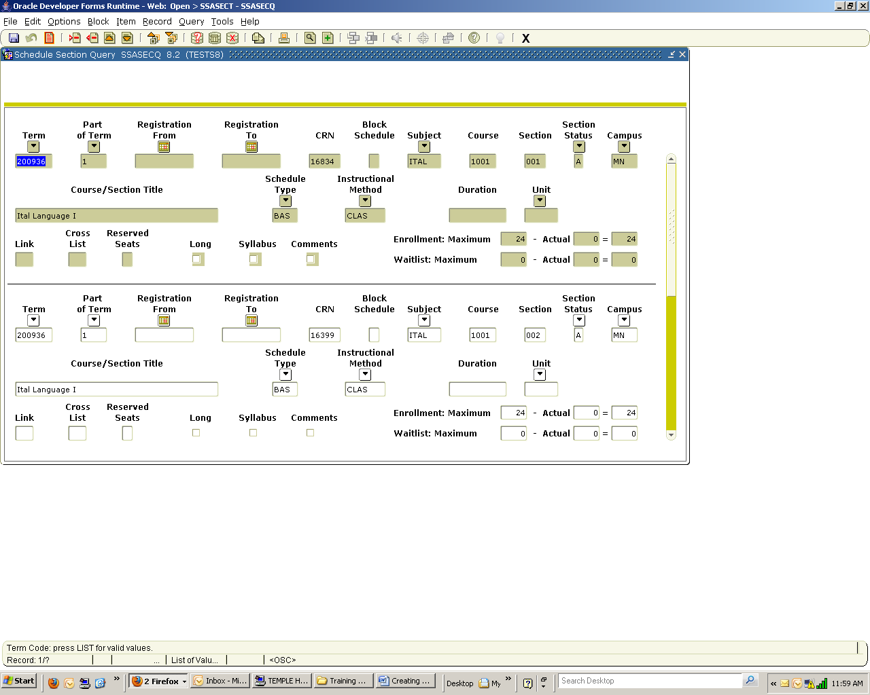
Keystrokes – Shift+F3
Menu Option – File> Select

Insert Record: Creates a blank row for the insertion of a record.
Icon -
Keystrokes – F6
Menu Option – Record> Insert

Remove Record: Deletes the record from the form.
Icon -
Keystrokes – Shift+F6
Menu Option – Record> Remove

Previous Block: Moves the cursor from one area or page of form to the previous one.
Icon -
Keystrokes – Control+Page Up
Menu Option – Block> Previous

Next Block: Moves the cursor from one area or page of form to the next one.
Icon -
Keystrokes – Control+Page Down
Menu Option – Block> Next
Current State vs. Future State
In this section we will compare ISIS fields and screens to Banner fields and forms.

ISIS S1 – SECTION UPDATE SCREEN 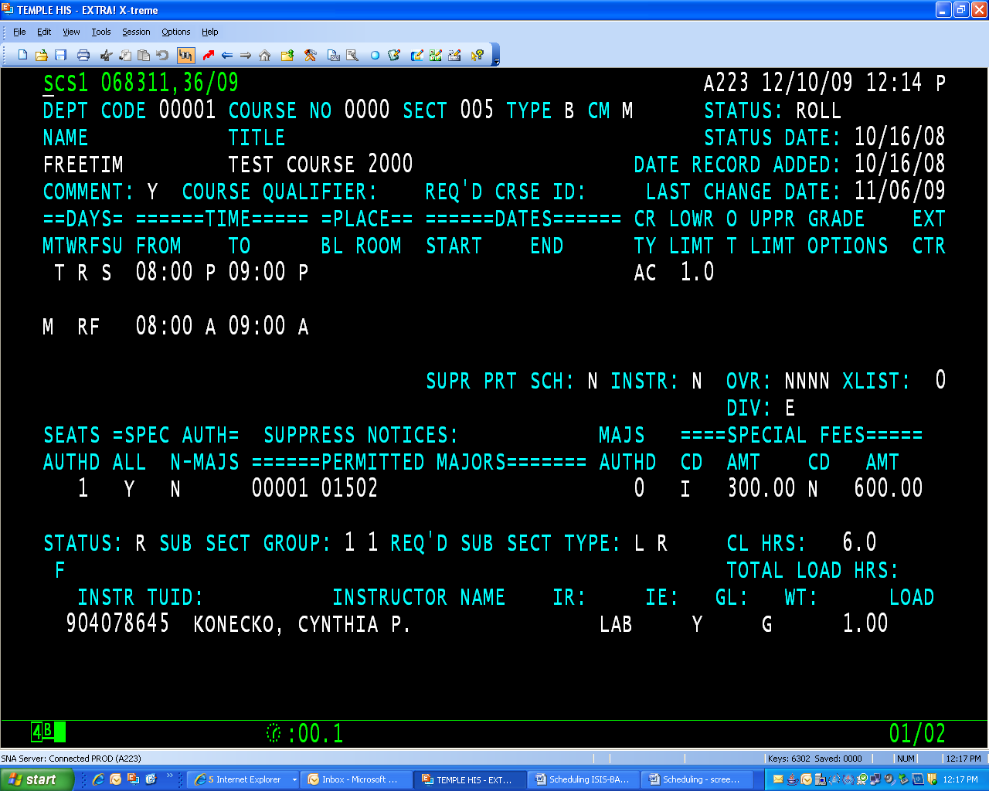

ISIS Fields BANNER Fields & Forms (SSASECT, SSADETL, SSARRES, SIAASGN)
S1 screen Fields referenced below are on SSASECT unless otherwise noted
CRN CRN
Term Term
Dept code On SCACRSE & references financial, not academic departments
Course No Course Number
Sect Section
Type (B/L/R) Schedule Type (base, lab, recitation, new codes, course qualifiers, etc.)
Note - Labs and Recitations can be gradable and offered for credit in Banner
Cm Campus
Status Status
Name Subject
Title Title
Status Date Not displayed on forms
Date Record Added Not displayed on forms
Last Change Date Not displayed on forms
Comment Flag Not available
Course Qualifier Converted as Schedule Types
Req’d Crse ID SCADETL
Days (up to 3) Meeting Times and Instructor tab (unlimited)
Times – From To (up to 3) Meeting Times and Instructor tab (unlimited)
Place – Bl Room (up to 3) Meeting Times and Instructor tab (unlimited)
CR TY Academic understood, unless CEU Indicator is checked
Lowr Limt Credit Hours
O/T To/Or radio buttons
Uppr Limt Credit Hours
Grade Options Grade Mode
EXT CTR Accommodated in Banner in STVCAMP with X prefix
Supr Prt Sched Print checkbox
Instr Print checkbox
Ovr Can’t locate any data that indicate that course and section level definitions differ.
Xlist Cross List (code defined on SSAXLST and entered on SSASECT or SSAXLST
Div Session
Seats Section Enrollment Information tab - Maximum
Spec Auth All Special Approval block
Spec Auth N-Majors SSARRES (may default from SCARRES)
Permitted Majors SSARRES (may default from SCARRES)
Note – Users are able to broaden the course restrictions at the section level
Authd Reserved Seats
Special Fees Cd Amt SSADETL
Status Status
Sub Sect Group Link Identifier
Req’d Sub Sect Type Link Identifier
CL Hrs Weekly Contact Hours
Total Load Hrs SIAASGN
Load SIAASGN
Instr TUID ID on Meeting Times and Instructor tab
Instructor Name Name on Meeting Times and Instructor tab
IR IE GL NA

ISIS S8 – SECTION COMMENTS SCREEN 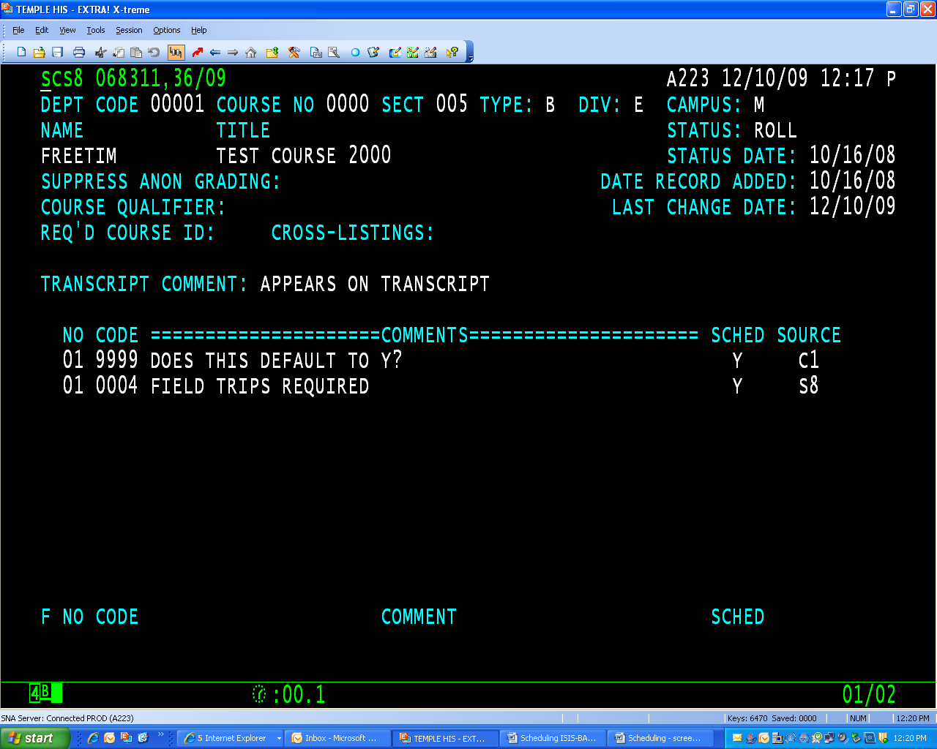

ISIS Fields BANNER Fields & Forms
S8 SSASYLB or SSATEXT
CRN CRN
Term Term
Dept Code Not displayed on these forms
Course No Course
Sect Not displayed on these forms
Type Not displayed on these forms
Div Not displayed on these forms
Camp Not displayed on these forms
Name Subject
Title Course Title
Status Not displayed on these forms
Status Date Not displayed on these forms
Date Record Added Not displayed on these forms
Last Change Date Not displayed on these forms

Suppress Anon Grading Not available, identified as a Gap
Question – How will Law School anonymous grading be accommodated?
Course Qualifier Converted to Schedule Types – Not displayed on these forms
Req’d Course ID Converted as Course/Degree Attribute - Not displayed on these forms
Cross-Listings Entered on SSASECT or SSAXLST - Not displayed on these forms
Transcript Comment SSASYLB – Section Long Title*
Comments SSASYLB & SSATEXT for printed and online schedule only

*Procedural Issue – Must be selected for SHRROLL process.

Banner delivered Scheduling processes and reports.

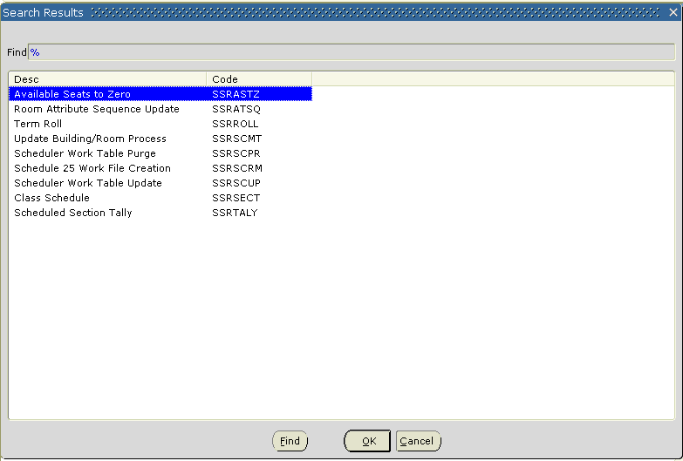
NOTES:

